Sources and fate of organic carbon in chemosynthetic and other Southern Ocean benthic ecosystems

Dr Clare Woulds

Introduction
Chemosynthetic ecosystems occur where reduced solutes, such as sulphide and methane, flux out of the seafloor, and so are usually associated with hydrothermal vents and cold methane seeps. They represent interesting and new settings for studies of benthic food webs, sedimentary carbon cycling, and microbiology. The presence of in situ carbon fixation, conducted by diverse assemblages of microbes, and resulting in hotspots of benthic biomass, clearly has implications for ecosystem C sources and flow pathways. However, chemosynthetic settings have not yet been fully characterised, and questions remain regarding the functioning of many/most of the organisms found in them. Specifically, it is not clear to what extent chemosynthetic ecosystems rely on in situ production, versus phytodetritus from the water column, nor which microbial processes are most active and important. Further, the fate and biological processing of phytodetritus in non-chemosynthetic settings on the seafloor surrounding Antarctica has not yet been directly quantified.
Therefore, this study aimed to conduct isotope tracing experiments to characterise and quantify C and N flow through chemosynthetic and non-chemosynthetic ecosystems of the Southern Ocean. 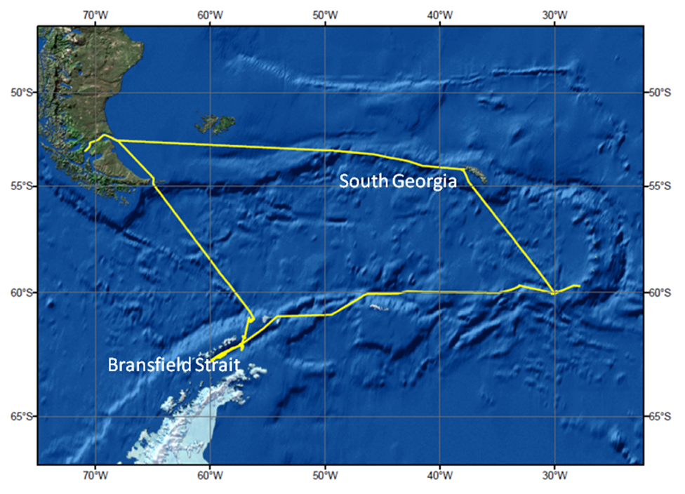
Figure 1. Cruise track of cruise JC55, courtesy of Tyler et al., 2011, JC55 cruise report.

Objectives
- To contrast in situ production and phytodetritus as C and N sources for chemosynthetic communities.
- To identify the main bacterial groups responsible for in situ production.
- To characterise and quantify the short-term fate (including faunal uptake, bacterial uptake and respirastion) of organic C and N in chemosynthetic sediments.
- To establish the role of archaea in benthic C and N cycling in both chemosynthetic and regular sedimentary environments.

Approach
Experimental
The award of an Antarctic Science Bursary allowed me to join sail on the RRS James Cook, as part of the NERC funded ChEsSO (Chemosynthetic Ecosystems of the Southern Ocean) project. During the cruise, in January and February 2011, isotope tracing experiments were conducted at two diffuse hydrothermal vent (Hook Ridge and Middle Sister) and one off vent site in the Bransfield Strait, and at a methane seep site off South Georgia (Fig. 1).
At each site four replicate sediment cores were collected from and isotopically labelled substrate was added. Two of the four cores received ¹³C and ¹⁵N labelled algal cells (dead), which were allowed to settle onto the sediment surface (dose = 435 mg C m⁻²). The other two cores received ¹³C bicarbonate (dose = sufficient to make surface 3 cm of pore water 1 mM labelled bicarbonate) and ¹⁵N ammonium (dose = sufficient to make surface 3 m of pore water 7μM labelled ammonium). In this case the solutions were injected into the pore waters of the surface 3cm. Cores were sealed using custom built core tops, equipped with magnetic stirrers and sampling ports, and incubated at in situ temperature for ~48 hours. Every 12 hours a sample of core top water was withdrawn and preserved for isotopic analysis of isotopes in dissolved inorganic carbon and NH₄⁺. Experiments were terminated by extruding and sectioning the cores. Half of each slice was frozen (-80°C), and half was preserved in formalin for subsequent sieving and extraction of macro and meiofauna. Macrofauna were extracted from roughly one third of samples during the cruise. Organisms were
identified (to family level for polychaetes) with the help of Dr Adrian Glover (Natural History Museum), and stored frozen in pre-weighed, ultra-clean silver boats.

Observations
- The only site which showed visual evidence of chemosynthesis was Hook Ridge. At this site Siboglinid polychaetes were present, and the sediment exhibited an iron rich band, and sulphide deeper in the core.
- The off-vent site was also reported to host Siboglinid polychaetes, thus suggesting that it was not completely free of chemosynthesis. The three Bransfield Strait sites will provide an interesting comparison as they are likely to show varying dominance on chemosynthesis.
- The middle Sister site may not have been chemosynthetic, however the biology is still interesting. Mudballs (possibly foraminifera) were present on the sediment surface, and large (visible) polychaetes were also present.
- The South Georgia site features methane rich pore waters, and evidence of anaerobic oxidation of methane at 10-15 cm. It therefore seems likely that it will show evidence of chemosynthesis (anaerobic oxidation of methane and methanotrophy) in isotope tracing experiments.

Analytical Plans
Fauna
Macrofaunal extraction will be completed when the samples arrive in Leeds. Samples will be analysed for ¹³C and ¹⁵N at the Macaulay Institute. Meiofauna will be extracted, identified, and analysed by MRes students at NOC, in collaboration with Dr John Copley.
Overlying Water
Time-series samples of overlying water will be analysed for ¹³C in DIC, either at NERC LSMSF (Lancaster), following a NERC facility application, or at KU Leuven, Belgium (lab of Dr Stephen Bouillon). The decision will be driven by funding availability, and the methods used at the LSMSF.
Frozen water samples may also be analysed for ¹⁵N in NH₄⁺, in collaboration with Dr Dalsgaard (Denmark), or at NIOO (the Netherlands), depending on progress with method development.
Sediment
Phospholipid fatty acids will be extracted from sediment samples and subjected to compound-specific isotope (¹³C) analysis, preferably at Bristol, following a NERC LSMSF application (submitted April 2011). The application will also include a proposal to conduct compound specific isotope analysis on a range of microbial biomarkers, including archaeal markers. This work will be in collaboration with Dr Rich Pancost (Bristol).
Sediment samples will also be subjected to DNA extractions, for tracing of ¹³C into microbial DNA (DNA-SIP). This work will be in collaboration with Dr David Pearce (BAS), and Colin Murrell at Warwick, and planning for this is already underway.

